Soil Texture Lab Name:

The mineral particles in soil are classified in three main categories based on particle size. The larger particles are **sand**, somewhat finer particles **silt**, and extremely fine particles are **clay**. The relative amounts of sand, silt and clay in a given soil make up its texture. Most soils are a mixture of these particles and organic matter, out may have more of one size particle than another. If a sample has equal amounts of all three particles it is called **loam**. Loam is considered the best type of soil for growing most plants. A soil's texture determines how much water it can hold and how rapidly water will percolate through the soil. The best soils for growing crops have good air circulation and drainage yet retain enough water for good plant growth.

The **''Feel Method"** for determining Soil Texture.

Moisten your index finger with water and rub a little bit of soil between your thumb and index finger. Sand particles feel grainy or gritty, silt particles feel silky or smooth and clay particles feel sticky / oily and can be pressed or squeezed into small ribbons between your thumb and finger. Use the soil texture chart to determine the texture of your soil.

**LaMotte** Test kit Procedure:

1. Place the Soil Separation Tubes in the rack.

2. Add the soil sample to Soil Separation Tube "An until it is even with line 15.

Note: Gently tap the bottom of the tube on a firm surface to pack the soil and eliminate air spaces.

3. Use the pipette to add 1ml of Texture Dispersing reagent to the sample in Tube A.

4. Dilute to line 45 with tap water.

5. Cap and gently shake for two minutes, making sure the soil sample and water are thoroughly mixed.

The sample is now ready for separation. The separation is accomplished by allowing a predetermined time for each fraction to settle out of the solution. Be sure that you continue to ­gently shake the separation tube up to the start of step 6.

6. Place Soil Separation Tube "A" in the rack. Allow to stand undisturbed for exactly 30 seconds.

7. Carefully pour off all the solution into Soil Separation Tube "B”. Return Tube "A" to the rack. Allow Tube "B" to stand undisturbed for 30 minutes. Return to your seats for instructions.

8. Carefully pour off the solution from Soil Separation Tube "B" into Soil Separation Tube "C". Return Tube "B" to the rack. –

Calculations:

% of sand = Reading of Sediment in "A” X 100

Initial Volume of Soil

% of silt = Reading of Sediment in "B” X 100

Initial Volume of Soil

% of clay = [ 15 – (reading in A + reading in B)] X 100

Initial Volume of Soil

Use the soil texture chart to determine the texture of your soil.

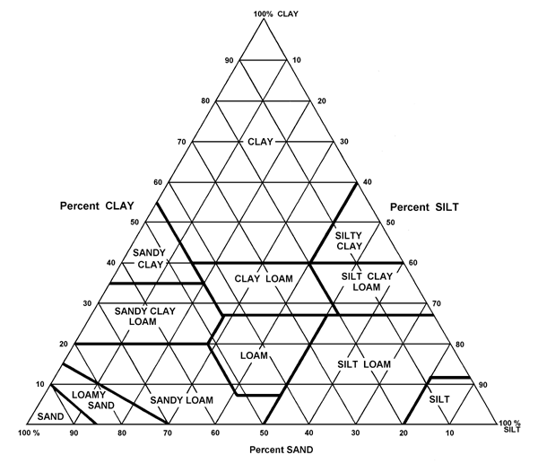

Analysis:

1. What was your soil texture using the “feel method”?

2. What was your soil texture using the LaMotte test kit?

3. Which method do you think is most accurate?

4. A soil scientist performs much of their research in the field, far away from a laboratory. Why do you think the “feel method” is often used?